


Cutlery Skills

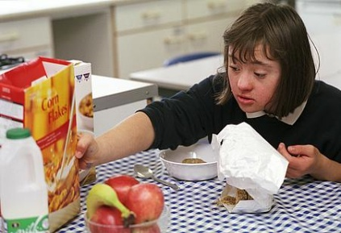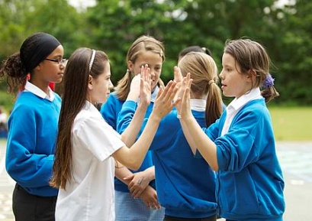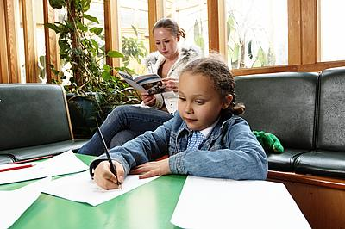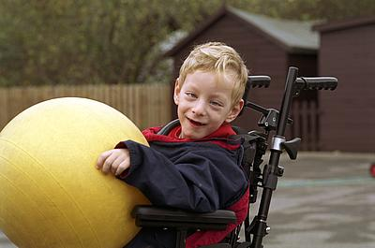
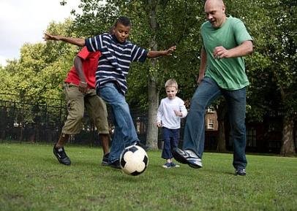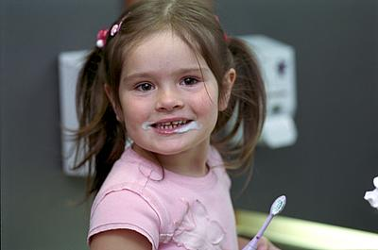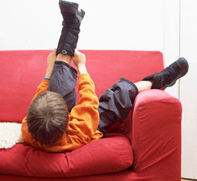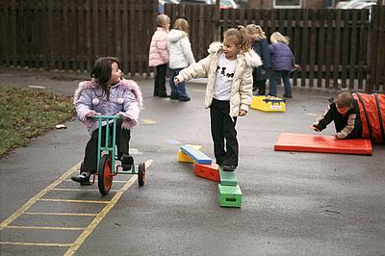

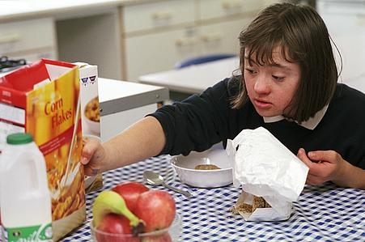
Community Paediatric Occupational Therapy Department

Introduction
Using a knife and fork to cut up food can be difficult for some children to learn as they need to be able to do different things with each hand. If using cutlery is difficult for a child they will often end up eating with their fingers or spilling their food over the table as they pull or tear at their food with the knife and fork rather than cutting carefully.
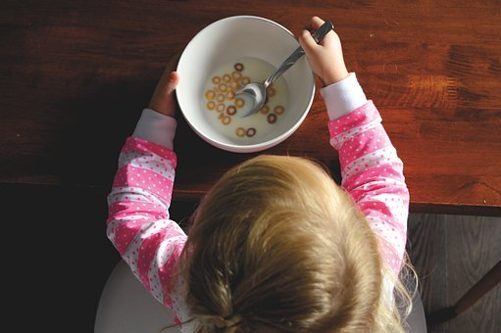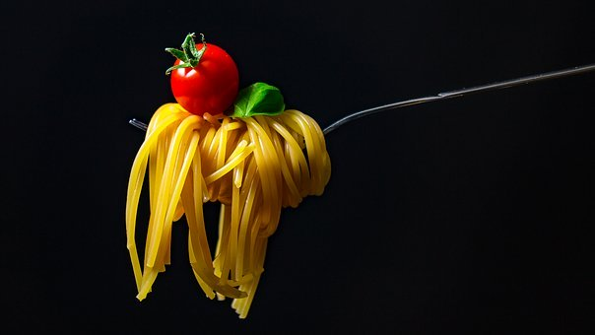
If your child is struggling to learn to use cutlery, they might benefit from doing some of the following activities. These activities use some of the same skills they will need for using cutlery and will give your child opportunity to practice the skills other than at mealtimes.
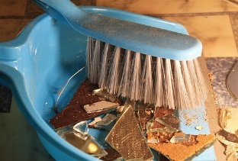
Activities to develop two handed skills
Any games or activities which encourage your child to hold one hand still whilst moving the other hand will help with the basic skills for using cutlery.
- Using a dustpan and brush – make sure your child keeps the dustpan still and only moves the brush. Your child may want to move both together at the same time;

- Using scissors – start with easy patterns e.g. straight lines, triangles and squares. Once they can cut these easily, move them on to more difficult designs e.g. circles, wavy lines or non-symmetrical shapes;
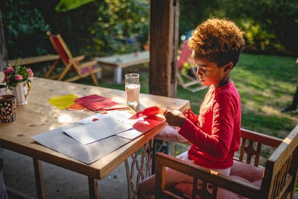
- Using Play Doh® – encourage your child to practice using cutlery whilst they are playing with Play Doh®;

- Cooking / Baking – holding a bowl while mixing with a spoon or spooning the mixture out of the bowl;

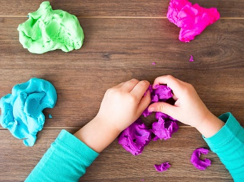
- Colouring – ensure your child holds the paper with one hand whilst the other hand does the colouring;

- Opening screw top bottles and jars;

- Construction games – e.g. Meccano®, K’NEX®, LEGO®
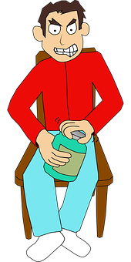
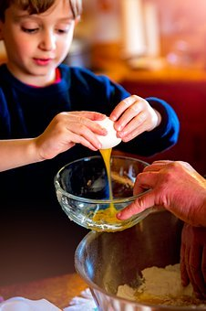
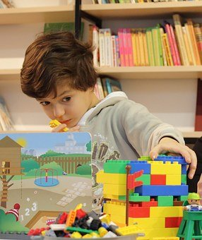

Tips for Mealtimes
Mealtimes are more than just learning to eat without a mess. Your child will learn more quickly if they don’t feel pressure and can develop these skills at their own pace.

- Ensure your child is sitting at a table and chair so that their feet can rest on the floor or a box ad their arms can rest on the table;

- Ensure the plate does not slip by using an oil cloth/wipeable tablecloth, dycem or non-slip mat or blu-tac to stick the plate to the table;

- Encourage your child to practice cutting in other situations first and let them decide when they are ready to try at mealtimes;

- Help them to hold their cutlery so that they are successful when cutting i.e. make sure they hold the knife with the blade facing down;
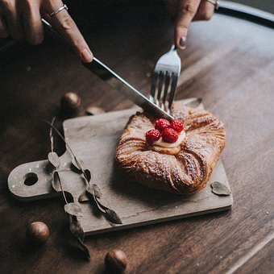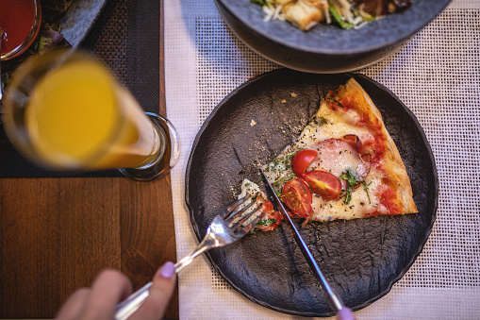
- If your child is struggling to hold cutlery they might find Caring Cutlery helpful. These have a molded grip with an indent to help your child feel where to put their index (pointing) finger. These are widely available online and come in junior or adult sizes.
Tips for Developing Cutting Skills
- When your child is ready to start using a knife and fork at mealtimes, do not expect them to practice more than two or three cuts to start with;

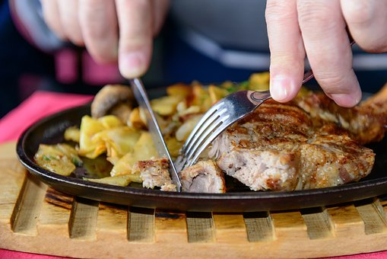
- Encourage them to slow down and think about each stage of cutting e.g. stab with the fork, slide the knife down the back of the fork and then saw back and forth with the knife;

- If your child will let you, stand behind them and with your hands on theirs and help them hold the fork still whilst cutting the food with their knife. Expect them to be untidy when cutting; they may tear their food at first;

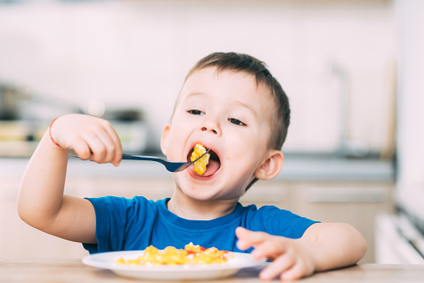

- Applying the right amount of pressure to a knife as well as cutting with it can be difficult. To help your child learn this skill try giving them foods of different textures ranging from firm e.g. sausages to soft e.g. fish fingers. Talk about how difficult or easy it is to cut and how hard they may need to press. This will help your child learn to change the amount of pressure they use depending on the food they have;

- If your child struggles to use enough pressure, encourage them to put their index (pointing) finger on top of the cutlery rather than wrapping the whole hand around the handle. This is when Caring Cutlery mentioned above might be useful;

- If your child holds their knife too tightly they may find cutlery with thick/chunky handles useful;

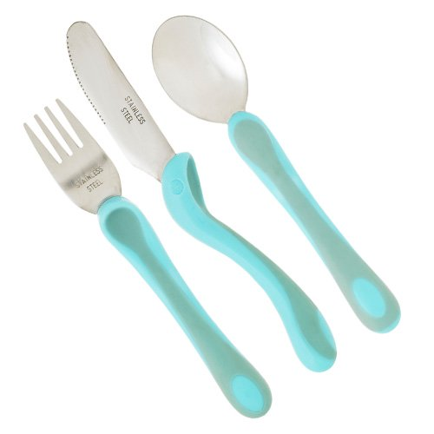
Cutlery Information
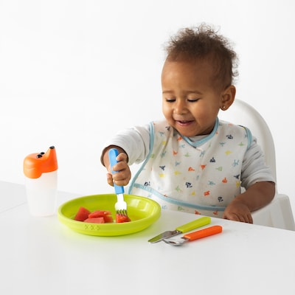

Completecareshop.co.uk
Ikea.com

Mealtimes are an important aspect of family life. Children begin to develop self-feeding skills from birth. Self-feeding is a very complex task and it is common for children to have difficulty using cutlery to feed themselves. It usually takes until a child is 7 years old before they can successfully use cutlery to feed themselves without being too messy.
There are a variety of tools that can be used to support children with mealtimes if they continue to find these skills challenging. Many of these are readily available and are not seen as specialist equipment.
There are a number of options in terms of cutlery. Spoons, forks and knives with thick and/or textured handles are easier to hold. A spoon, fork or knife with a short handle is easier to control. Encourage your child to try a variety of standard cutlery in the first instance. Consider the weight of the cutlery.
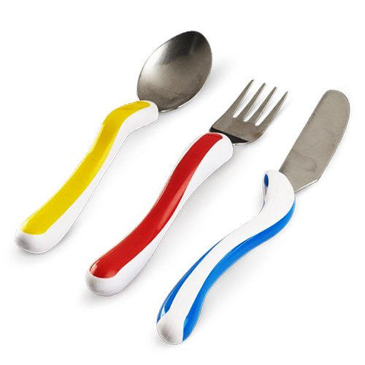
If your child is having difficulty placing their fingers in the correct places on cutlery you can put a sticker or a dot of nail varnish on the back of the knife or fork to show where their index “pointer” finger should go.

Caring Cutlery has an indentation where the index finger is to be placed and is ergonomically designed to fit the hand. This comes in junior and adult sizes and some other brands make something similar so shop around.

Completecareshop.co.uk
Information adapted from https://www.nhsggc.org.uk/kids

