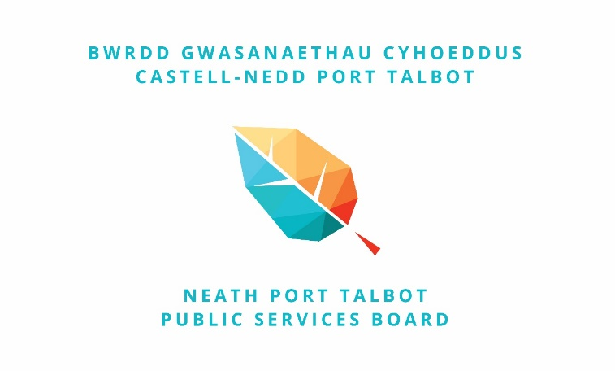

Annual Report May 2018 –June 2019

Aileen Flynn

Contents
Foreword 3
Our Vision and Well-being Objectives 4
Context 4
Vision 5
Well-being Objectives 2018-2023 6
Governance 7
A Summary of Progress 9
Well-being Objective One – Early Years: 9
Well-being Objective Two – Safe Resilient Communities: 13
Well-being Objective Three – Ageing Well: 17
Well-being Objective Four – Well-being in the Workplace: 21
Well-being Objective Five – Green Infrastructure: 23
Well-being Objective Six – Digital Inclusion 27
Other Work Progressed by the Neath Port Talbot Public Services Board in 2018-19 30
Board Development 30
Town and Community Councils 30
Substance Misuse 30
Early Years 31
Suicide Prevention 32
Physical Activity Alliance 32
Collaborative Working 33
How can you track progress and get involved in our work? 35
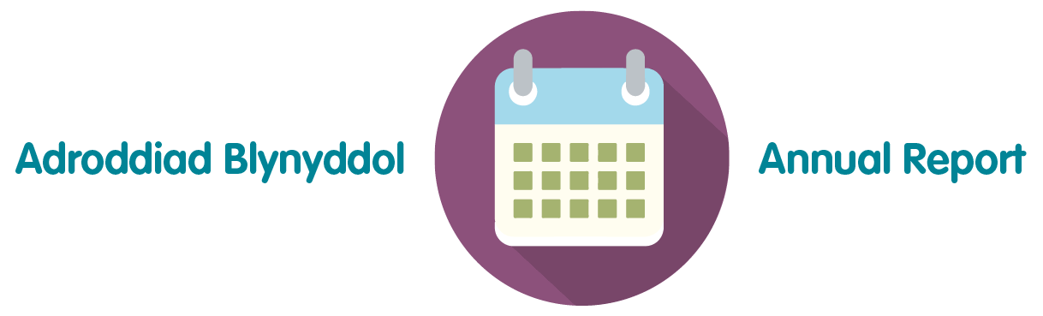

Foreword

The Neath Port Talbot Public Services Board published its Well-being Plan for the county borough – “The Neath Port Talbot We Want” – in May 2018, following a comprehensive assessment of the well-being of the local population and extensive consultation and engagement with a wide range of stakeholders.
This is our first annual report on the progress we are making towards the priorities we set out in our Plan. In addition to reviewing progress over the first twelve months, the Plan also looks forward to the next 12 month period and summarises the focus of work in the next planning period.
The Well-being of Future Generations (Wales) Act 2015 requires us to secure the economic, social, environmental and cultural well-being of local people and to do so sustainably. Whilst it is early days, there is evidence we are beginning to respond to the challenges set in the legislation for us to work together in different ways –between organisations and between organisations and our communities.
We hope you will be interested in the work we are doing and would welcome ideas and contributions that can bring about change that creates the Neath Port Talbot we all want.

Cllr Rob Jones Roger Thomas
Chairperson Vice-Chairperson

Our Vision and Well-being Objectives

Context

The Welsh Government established public services boards to encourage local organisations to work together and with the local population to improve the well-being of the people who live in their area. The way in which the Welsh Government wants to see this carried out in practice is set out in the Well-being of Future Generations (Wales) Act 2015 and other guidance.
The Neath Port Talbot Public Services Board held its first meeting in May 2016. It brings together a range of agencies whose details can be found in the appendices. (Appendix 1)
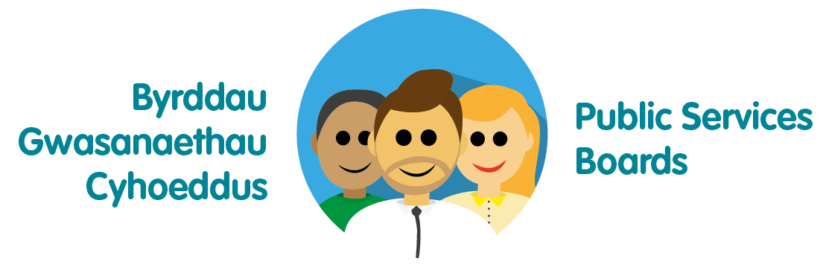
The first main task the Board was required to undertake was a comprehensive assessment of the well-being of the local population. Our Well-being Assessment includes a range of statistical information about the many things that can impact on well-being such as: levels of crime and disorder; and educational attainment etc., as well as data about aspects of well-being such as: mortality rates; and prevalence of disease etc. The Assessment also gathered views from a wide range of people to provide the Board with insight into what people consider is important to their own well-being, what’s good about the current situation and what needs to be improved most. Finally, the Well-being Assessment included a Future Trends Report which set out a number of issues likely to impact on well-being over the next 30 years or more. For example, climate change risks; the growth in digital technologies; food and fuel supplies – to list just a few examples.
The Well-being Assessment was published on our website and its findings were used by the Board to prepare our Well-being Plan and the priorities contained within that Plan. In deciding upon the priorities, the Board felt it was important to select issues where the Board had the opportunity to make the biggest difference. The Board consulted on the draft Plan over the autumn of 2017 and took into account views provided from stakeholders, together with advice provided by the Future Generations Commissioner, when finalising its initial programme of work. The Well-being Plan was published in May 2018.

You can find out more about our Well-being Assessment and our Well-being Plan by following these links:
Assessment http://wellbeingsite.dns-systems.net/index.php/en/home/
Plan http://www.nptpsb.org.uk/

Vision

We want Neath Port Talbot to be a vibrant and healthy place where people have an equal chance to get on in life – a place where people want to live, learn, work, invest and visit for many generations to come.
We want local public services, including the Third Sector, to be effective and value for money, easy for people to use, and offer quality employment where people are valued and appreciated for the work they do. Together with citizens, we will build on our strong and cohesive communities where the rights of everyone will be respected and protected.
We want our public services to be focused on enabling people and communities to be resilient and it will be the norm for citizens to experience seamless, personalised, high quality services. Public service delivery will create the right conditions for investment that will enable the county borough to attract and sustain quality, sustainable employment for local people.
Our communities will be well connected through a first class digital and transport infrastructure and our natural environment will be protected but also developed to support healthy living and investment.
We will have achieved our vision when all children and young people have the best start in life; when all young people and adults have the skills and resilience to be healthy and prosperous; when people are safe and feel safe; when all of our communities are thriving and supporting the people who live there; and where people can draw on the support of neighbours and well-developed social networks.

Well-being Objectives 2018-2023

We decided to focus on four well-being objectives:
- To improve the well-being of children in their early years, especially those at risk of adverse childhood experience (Lead: Lead Director for Children and Young People, NPT Council);
- To build safe, confident and resilient communities, focusing on vulnerable people (Lead: Director of Social Services, Health and Housing, NPT Council and Director of Neath Port Talbot CVS);
- To create an environment where everyone can age well (Lead: Deputy Chief Fire Officer, Mid and West Wales Fire and Rescue Service); and
- To support well-being through work and in the workplace (Lead: Chair, Swansea Bay Health Board).

However, through discussion we also decided to address two cross-cutting issues:
- Protecting and enhancing our green infrastructure (Lead: Regional Manager, Natural Resources Wales);
- Increasing levels of digital participation/inclusion (Lead: Assistant Chief Executive, Council).

Governance
Each well-being objective and cross-cutting theme has been led/sponsored by a member of the NPT Public Services Board. The Plan set out a range of steps that the Board intended to take to achieve the well-being objectives or themes. Each lead officer has drawn together a range of stakeholders to work out how the steps might be best progressed. There have also been regular meetings of the lead officers to ensure that the work of the Board is seen holistically.
In developing the detail of the work programmes, lead officers have also tried to embrace the sustainable development principle:
- Integration – considering how the PSB’s contribution to the well-being objectives may impact upon each of the Welsh Government’s well-being goals, on its own well-being objectives and on the objectives of other public bodies;
- Collaboration – acting in collaboration with any other persons (or different parts of the PSB itself) that could help the PSB to meet its well-being objectives;
- Involvement – the importance of involving people with an interest in achieving the well-being goals and ensuring that those people reflect the diversity of the area which the body serves;
- Prevention – how acting to prevent people occurring or getting worse may help public bodies meet their objectives; and
- Long Term – the importance of balancing short-term needs with the need to safeguard the ability to also meet long term needs.


Lead officers have also considered how their work contributes to the well-being goals established by the Welsh Government in the Well-being of Future Generations (Wales) Act 2015:
- A prosperous Wales;
- A resilient Wales;
- A healthier Wales;
- A more equal Wales;
- A Wales of cohesive communities;
- A Wales of vibrant culture and thriving Welsh language; and
- A globally responsible Wales.
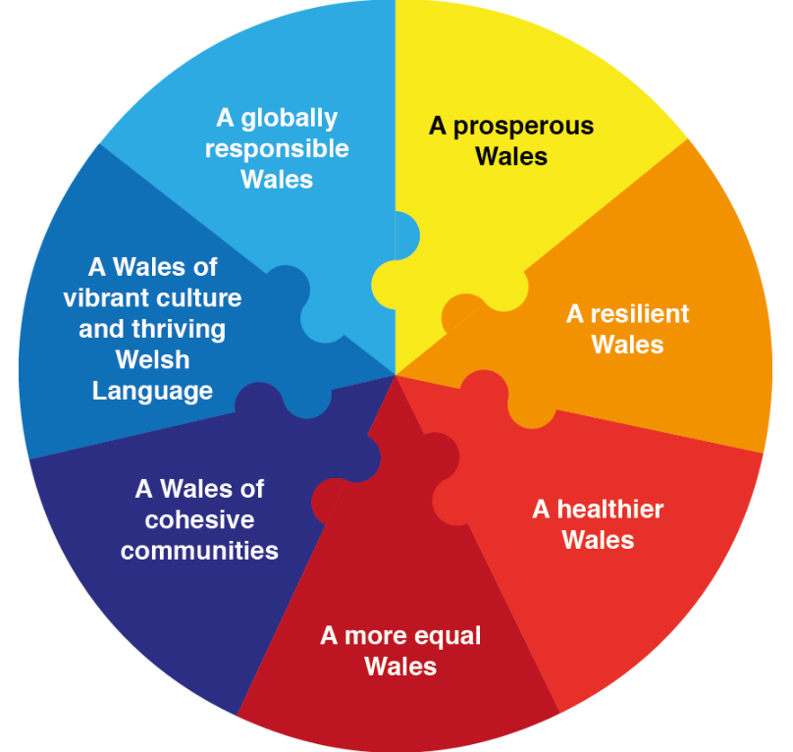
In the next section you will find a summary of what we have done so far and what we plan to focus on in the next twelve months.
During the year, the Neath Port Talbot Public Services Board also came together with the City and County of Swansea Public Services Board and agreed that acting jointly on the rate of drug-related deaths, levels of serious infections acquired through opioid injecting practices and a new phenomenon – county lines – required a heightened, multi-agency response. You can read more about this work later in this document.
The Board also participated in a number of programmes run by the Welsh Government and explored how it might collaborate regionally and locally in moving its work forward. Some of the ideas we have generated as to how we could do this are also set out later in this report.

A Summary of Progress

Well-being Objective One – Early Years:
To improve the well-being of children in their early years, especially those at risk of adverse childhood experience (Lead: Lead Director for Children and Young People, NPT Council).

Partners/Stakeholders Involved:
Children and Young People’s Partnership; families, community groups, service providers and schools in the Sandfields West area; local elected members in the Sandfields West area; First 1,000 Days Programme; Early Action Together; Early Years Pathfinder Programme; Families Connect; Flying Start; Families First.

Key Achievements during 2018-19:
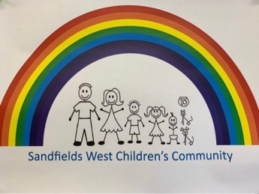A multi-agency group was established to develop a children’s community zone in Sandfields West - a pilot project based on similar work undertaken in Hackney, London. Key principles and a vision have been developed in partnership to guide the project. The learning from the pilot will be used to develop approaches across the county borough to secure a more cohesive and collaborative approach to supporting children in their early years. The project has a delivery plan that identifies key actions and milestones. Progress is monitored against these aspects.
All early years and primary school provision in the area was mapped as were those services that support parents and young people when they become adults. An external consultant also undertook engagement with parents and organisations working and living in the area.

During the year the Neath Port Talbot Public Services Board also agreed to participate in the Welsh Government’s First 1,000 Days Programme. This programme considers the period from conception to the age of 2 years of age and seeks to identify those families where there is a risk that children in this age range could experience adverse childhood experiences. There is now significant evidence that when children have such experiences that their well-being can be severely affected. An early action in the Programme was to get all front line practitioners together to discuss how well the existing early years services work. As well as providing the foundation of work that will be taken forward by the Children and Young People’s Partnership, the event also helped identify some gaps in provision in the Sandfields West area, as well as highlighting features of services in the area that were seen to be working well.
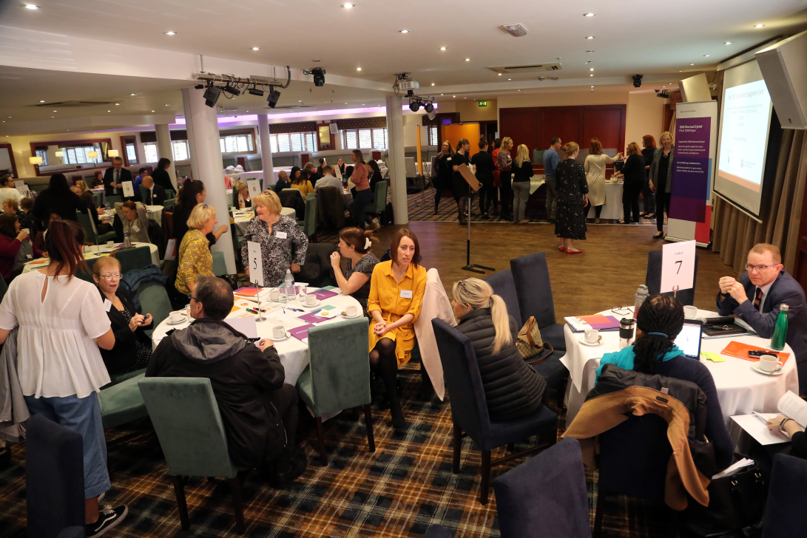
Early consideration has been given by partners to the issue of information sharing. Whilst there are a range of good information sharing arrangements in place, it was agreed that some information sharing protocols need to be improved to ensure they can effectively support the needs of children in their early years and in preparing children for school; in particular, for those families who would benefit most from additional support.
Towards the end of the year, Welsh Government also sought interest from public services boards for participation in an early years pathfinder programme. It was agreed that it would be useful to become involved in the pathfinder programme so that the local work can benefit from the research and learning that will be developed across Wales. The pathfinder is a joint project with Swansea Council and this will provide opportunities for us to share practice on a wider basis and develop shared approaches where appropriate. Furthermore, the Police and Crime Commissioner secured a transformation grant to focus work on early years – Early Action Together. Discussions are underway to ensure that there is coherence across all of these programmes with a clear focus on testing the new approaches as part of the pilot project in the Sandfields West area.

A Case Study:
Since October 2018, the local authority has employed a 30 hour per week Children’s Community Lead to engage with identified families and to coordinate activities aimed at:
- Promoting better parenting;
- Ante-natal support with health visitors;
- Emotional health and well-being support;
- Sleep clinic;
- Advising parents on routes back into work in partnership with Communities Work+;
- And a range of other activities.
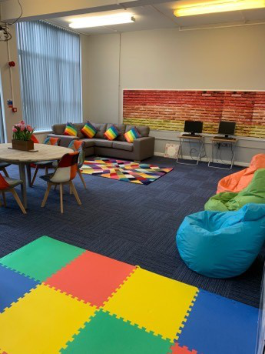These activities are delivered from a purposefully modified family friendly space located at Tir Morfa.
During a three month period we have engaged with 59 partners and 53 participants have been directly supported.
In one instance, a parent who had clearly disengaged with support services met with the Children’s Community Lead at a coffee morning event and reported social emotional issues with her teenage daughter. This led to a detailed discussion and a building of trust between the employee and the parent. As a result, the parent self-referred to SPOC (single point of contact) to seek more specialist support for both her and her daughter. The parent has reported a significant level of trust in the Children’s Community Lead and feels able to discuss issues openly that would, otherwise, have been causing significant tension and anxiety within the family setting.
This demonstrates the value of building relationships with community members and breaking down barriers that are clearly causing difficulties for individual families. The current model is based on high visibility and activity aimed at securing quality engagement with families.
Families engaging with this model generally report a higher level of confidence in being able to talk about issues in their lives and in their ability to seek support. The current feedback from families shows that support in relation to emotional health and wellbeing, behaviour and parenting are the key priorities. The engagement sessions inform future provision and allow us to develop a more coherent early intervention and prevention approach.

Next Steps
- Agree criteria to identify ‘vulnerable’ families.
- Identify any gaps in provision. This has been underpinned by work undertaken in conjunction with the First 1000 days workshop that has allowed us to benefit from a range of views and insights from service providers.
- Identify barriers to accessing services.
- Establish a local reference group (include children and young people).
- Develop an appropriate evaluation framework to understand the effectiveness of the Children’s Community model, in terms of community participation and impact on users.

Well-being Objective Two – Safe Resilient Communities:
To build safe, confident and resilient communities, focusing on vulnerable people (Lead: Director of Social Services, Health and Housing, Council and Director of Neath Port Talbot CVS).

Partners/Stakeholders Involved:
Neath Port Talbot County Borough Council; South Wales Police; Neath Port Talbot Council for Voluntary Services; Swansea Bay Health Board; Tai Tarian; Public Health Wales; Mid and West Wales Fire Service; elected members of Neath Port Talbot Council; elected members of town and community councils in the Melyn, Neath, Briton Ferry and Amman Valley; community groups; local shop keepers; faith leaders; volunteers and residents; as well as service providers and community leaders in the two pilot areas of Melyn/Briton Ferry and Amman Valley; West Glamorgan Regional Partnership Board.

Key Achievements during 2018-19:
A leadership group has been formed with chief officer representatives drawn from Public Services Board partners. The leadership group is supported by a Strategic Group, chaired by an officer from the Swansea Bay Health Board which draws together those service managers and stakeholders that can help move this work forward. Two operational groups are in the process of being established – one for each of the pilot areas with the intention that membership of these groups will be drawn from those who are working on the front line within the communities concerned.
A wide ranging engagement exercise of key community leaders was carried out by the Director of Social Services, Health and Housing and the Director of the Neath Port Talbot Council for Voluntary Services to test support for the work. Additionally, a number of workshop sessions have been held for the leadership group and strategic group to secure a shared vision and commitment to the programme.
A Transformation Bid was made through the Regional Partnership Board for financial resources to deliver the work in the two pilot areas. This funding will be targeted at building community capacity and at training the public services (including the Third Sector) workforces. It is intended that the benefits of working in an asset-based model will be evaluated prior to scaling the approach up across other areas of the county borough.
Community asset mapping has begun and the first phase of a communications and engagement plan has also been developed. Additionally, the workforces operating in the two areas have been assessed and a proposed training plan has been developed. A small number of dedicated posts are to be established to support the work in both statutory agencies and in the Third Sector.
Following reflection, it has been agreed that the work will not focus exclusively on vulnerable people but will include the whole of the community.

A Case Study:
Every community has assets, facilities, businesses, parks, forests but most importantly the people and their capacities, organised community groups and individuals who have skills and talents. All these need to be mapped to create a picture of the community which shows its capacity and potential.
An asset based approach is a shift in mind set and practice for people who want to work with communities on issues of importance. The programme is about focussing on what is strong not what is wrong with our communities. It aims to make enough small changes to begin a culture change in how communities support each other.
Together we’ve learned that approaches need to be flexible and adaptable, recognising the uniqueness of people and places. If we are to do things differently, we need to be more experimental, learning from what does and doesn’t work in practice. That is what the Building Safe and Resilient Communities aims to do. Local Area Coordinators have a key role to play in supporting communities to support themselves. An example of such pieces of work involving Local Area Coordinators is narrated below:

Breaking the isolation
A referral was received from a housing association regarding an ex-service man. As a result of health issues he has become more house bound than he was used to being, having previously always been very active, with a love for art and dogs. Although he was faced with challenges as a result of his health, he did not want to have a carer or other social support because he did not want to be, as he felt he would be, a nuisance or burden to others. He agreed to meet with the Local Area Coordinator, who explored his rich and creative past, in doing so, discovered he had been a film extra on several locally made films and TV programmes. This has led to setting up at a local film club a special screening of those films he was in with a question and answer session afterwards. This has now led him to being more outward focused again, which was what he needed to prevent his isolated state
The Local Area Coordinators often meet those who have become socially isolated, many have interests and talents, but due to life events such as divorces, bereavements and health issues have lost the confidence to engage with others. Working towards those interests can lead to bringing small groups together, such as gardening clubs, craft groups and social gatherings such as dining clubs.
Last Christmas, a Local Area Coordinator pulled all of the groups she knew about into a Christmas Party. During the party, one could hear stories of how those involved would describe their feelings of loneliness and isolation prior to becoming a part of the small local groups and how things had improved and changed for them as a result of their participation. The party was not only a celebration of Christmas but also in many ways a celebration of those Community Champions who had pulled together 96 isolated individuals to a very special Christmas Event.

Next Steps
The next steps for 2019-20 are:
- Recruit a dedicated staff team to work on the programme and ensure there is a common understanding of the aims of the programme.

- Implement the communication plan and process for communicating the programme to all partners, agencies, communities and individuals.

- Establish an operational group for each of the pilot areas to identify assets and opportunities for development within the community.

- Establish, promote and administer a community grant scheme in each of the pilot areas to support community activity.

- Review progress of the programme, identify the challenges and celebrate its achievements.

Well-being Objective Three – Ageing Well:
To create an environment where everyone can age well (Lead: Deputy Chief Fire Officer, Mid and West Wales Fire and Rescue Service).

Partners/Stakeholders Involved:
Older Persons Commissioner; Mid and West Wales Fire Services; Department for Work and Pensions; Neath Port Talbot County Borough Council; South Wales Police; Neath Port Talbot Council for Voluntary Services; Swansea Bay Health Board; Hywel Dda Health Board; Tai Tarian; Public Health Wales; Altzheimer’s Society;

Key Achievements during 2018-19:
Training to raise awareness and understanding of dementia was carried out, supported by funding sourced from the Western Bay Regional Partnership Board;
An expression of interest to work towards the Altzheimer’s Society’s recognition standard for being a dementia friendly community was registered and preliminary work completed to enable the Neath Port Talbot PSB to work towards recognition.
Links were made with the Falls Prevention Group within the Swansea Bay Health Board. It was identified that the Public Services’ Board work could most usefully concentrate on primary prevention activities, with the Regional Partnership Board concentrating on secondary and tertiary prevention. This will avoid duplication and ensure both partnerships work in alignment and add value to each other’s work.
Preliminary work was undertaken to assess the scale and scope of work to address loneliness and isolation affecting people in the county borough. The assessment has shown that this affects people of all ages and that whilst some people can be supported in community settings, for others, one to one support is required – at least in the initial stages.
Tai Tarian has progressed its work to address high cost credit and indebtedness experienced by their tenants. Working within the wider Alliance established by locally born actor Michael Sheen, Tai Tarian has developed a very detailed understanding of how the cycle of debt develops, the risks and opportunities to support people out of such circumstances as well as wider system changes that are needed for the long term. This work has the potential to have much wider application in the county borough.
South Wales Police have identified that older people often do not report crime and disorder. This finding will be fed into the Community Safety Partners – Safer Neath Port Talbot – for action.
Arrangements to support older people into work have also been considered within the group. There are a range of support services and programmes available within the county borough that can support older people to remain in employment or to secure employment but there are also barriers to employment for this age group which need to be explored in more detail. The Department for Work and Pensions has agreed to lead the next phase of work.
As well as getting work off the ground in relation to each of the areas of focus that was agreed by the Public Services Board and set out in the Well-being Plan, work has also been developed in relation to information sharing. Expertise has been identified to support partners to ensure, where needed, information can be shared confidently and legally.
Adopting the Making Every Contact Count model has also been considered. The approach is regarded as having significant potential for developing a public services workforce that adopts a common philosophy to the way in which each worker interacts with other workers and the public, with an emphasis on prevention and early intervention. Positive results already achieved by the Hywel Dda Health Board have been shared with Neath Port Talbot partners.
After an enthusiastic start to the work, progress was disrupted in the middle of the year as a result of key officers moving to different roles within their agencies. Towards the end of the year, there has been renewed engagement which should see positive progress made in the next reporting period.

A Case Study:
A household in Wales is in fuel poverty if they spend 10% or more of their income, including Housing Benefit, Income Support or Council Tax Benefit, on energy costs.
In 2015 around 291,000 households, equivalent to 23% of all households in Wales, were living in fuel poverty. For customers in social housing, the rate of fuel poverty is higher again, estimated at 27% in 2015. Whilst exact figures have proved elusive it is to be expected that, following every other social indices for Neath Port Talbot, it is to be found in the upper end of the spectrum.
The energy poverty premium means that those who can least afford energy are amongst those who have to pay the most. Tariffs in pre-payment meters are the highest. Premium periods are during the day which impacts on the housebound and unemployed.
Tai Tarian is one of the largest social landlords in Wales and has responsibility for over 9,000 properties across the Neath Port Talbot County Borough. They are committed to providing good quality housing and a range of services to help people manage their homes.
Tai Tarian are currently exploring options to provide new and existing tenants with access to cheaper fuel prices. If successful this scheme will provide access to lower prepayment tariffs and will hopefully ensure that their tariff remains within the lower quartile. Tai Tarian are also exploring the option of installing Smart Meters which, in turn, will help tenants manage their budgets. Therefore, there are no estimated bills which mitigate tenants getting into debt.
Whilst these initiatives are still in the development stage it is hoped that, if introduced, the impact of high fuel costs for low income families will be radically reduced.

Next Steps
- To design and deliver a ‘Making Every Contact Count’ (MECC) approach to fulfil the aims and objectives of the Ageing Well Strategy Group.
- To provide MECC training to multi-agency frontline staff.
- To provide an evaluative framework to measure short, medium and long term progress.
Overview
MECC is an approach that utilises the millions of day to day interactions that our front line staff have with residents to support them in making positive changes to their physical health and well-being. MECC enables the opportunistic delivery of consistent and concise healthy lifestyle information and enables individuals to engage in conversations about their health.
In order to achieve this objective it is proposed that training is delivered to public and third sector frontline staff to assist in the delivery of these key messages to our residents.
This training will enable frontline staff to provide information and key messages in respect of the following:
- Public Health
- Fire Safety
- Crime Prevention
- Combating loneliness and social isolation
- Fuel Poverty
- Dementia Awareness
For staff, MECC means having the competence and confidence to deliver healthy lifestyle messages and the encouragement for people to change their behaviour and to signpost to local services that can support them to change.
MECC is not about:
- Adding another job to already busy working days
- Staff becoming specialists or experts in certain lifestyle areas
- Staff becoming counsellors or providing ongoing support to particular individuals
- Staff telling somebody what to do and how to live their life.
In addition the MECC project will need to ensure that stakeholders are compliant with the GDPR in relation to sharing of data.

Well-being Objective Four – Well-being in the Workplace:
To support well-being through work and in the workplace (Lead: Chair, Swansea Bay Health Board).

Partners/Stakeholders Involved:
Swansea Bay Health Board; Ford Motor Company; Tai Tarian; Neath Port Talbot County Borough Council; Mid and West Wales Fire and Rescue Service; Natural Resources Wales; Neath Port Talbot Council for Voluntary Services; Public Health Wales.

Key Achievements during 2018-19:
It was agreed that the initial focus of work would concentrate on how improvements to well-being could be leveraged through the PSB partner organisations in their role as significant employers in the local area.
An initial workshop saw existing well-being programmes and initiatives in place in each of the PSB partner agencies being shared and recorded. Contact details for those interested in following up information shared at the workshop event were also shared.
A second workshop included presentations from Ford Motor Company and Healthy Working Wales with Tai Tarian and Public Health Wales describing how well-being initiatives might be measured and used to deliver further improvements in well-being through the workplace.
The disaggregation of the ABMU Health Board impacted on the degree of momentum that could be generated for this priority during the year, as the Health Board and associated partners were required to prioritise the work needed to transfer health services for the people of Bridgend to Cwm Taf Morgannwg Health Board. However, partners remain committed to this objective and 2019-20 should see more significant progress.

A Case Study:
Partners have shared best practice in supporting and promoting staff health and wellbeing within their organisations and offers to share developments across partner organisations have been made.
SBU colleagues presented the Staff Wellbeing Service that enables staff to access timely support for musculoskeletal and common mental health conditions via a single point of telephone access. This is supported and promoted by a network of over 340 Wellbeing Champions who receive training and development opportunities by attending bi-annual workshops, informing them of internal and external support to which they can signpost team members. The Champions also promote National health campaigns and facilitate wellbeing initiatives within their workplaces.

Next Steps
The following areas have emerged for potential focus in 2019-20 and members have been asked to consider their contributions and priorities:
- All members to review the “asks” and “offers” from the first workshop and to take this forward by making the connections themselves.
- Members to share their health & wellbeing promotion campaigns or their approach to implementing National campaigns in order to promote ideas/good practice and reduce duplication of work.
- Mental Health – interested members to work toward a joint strategy.
- Mental Health Manager Training - possibilities of joint commissioning.
- Measure and Metrics task and finish group – this was an action agreed at the October workshop but capacity to undertake the work appears limited at the present time.
- All members to ensure consistent attendance to the group/meetings of staff that are in a decision making position within their organisations to ensure progression of work and action to take the work forward.
- Consideration be given to including other major employers in the area, e.g. the DVLA, Tata Steel, etc., in this well-being work stream)

Dedicated Project management resource will be required to ensure the continuation of the work stream and to support partners in formulating and delivering agreed outcomes.

Well-being Objective Five – Green Infrastructure:
Protecting and enhancing our green infrastructure (Lead: Regional Manager, Natural Resources Wales.

Partners/Stakeholders Involved:
Natural Resources Wales; Neath Port Talbot County Borough Council; Swansea Bay Health Board; Public Health Wales; Bridgend CBC, City and County of Swansea Council; community groups and residents in the Taibach/Margam area.

Key Achievements during 2018-19:
A multi-agency steering group was formed to take forward the work set out in the Well-being Plan and this Group bid for and secured funding under the Welsh Government’s GI Capital Grant Programme.
More detailed mapping of the green and blue space in Neath Port Talbot was undertaken, building on the work done for the Area Statements and the Well-being Assessment. Demand and opportunity maps were created for a range of issues including: air quality; access to green space; flooding; and carbon sequestration.
A pilot area was selected – Margam and Taibach – as a site where working together could deliver multiple benefits. Groeswen Playing Fields was identified for GI enhancement and design for the site was developed by landscape consultants. Local residents were involved throughout.
The project is now at delivery stage which will provide seating; improved access; improvements to the mowing regime to support pollinator species; tree planting to benefit air quality; and building in benefits for biodiversity and the visual look of the area. Learning from the work is being captured to inform further work across the county borough.
In February 2019, a workshop was held with partners to explore areas that might be developed to support well-being. One of the immediate benefits of the workshop was to form a network of interested organisations and volunteers. Ideas of where the work on GI can support the other well-being objectives of the Public Services Board were also captured and will be considered by the Steering Group when deciding the actions to be taken forward in the next period.

A Case Study:
As part of our SW Area Statement process, we trialled a creative new approach to identifying opportunities to deliver SMNR. We combined the brains of our local experts, giant acetate maps and special coloured pens in an innovative workshop format.
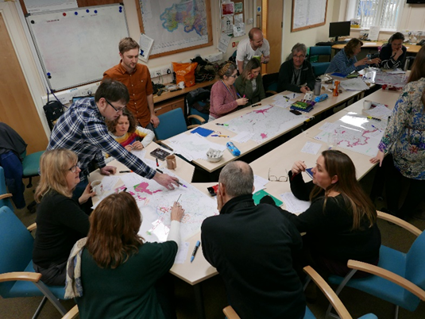
The session was designed as a hands-on way of identifying and exploring the opportunities to improve the resilience of our ecosystems. We encouraged participants to discuss their idea with the group before choosing a unique colour and drawing their opportunity on the overlay of the map. Forms corresponding to each map-drawn opportunity were filled out providing more detail about the opportunity and the issue/s it was aiming to resolve.

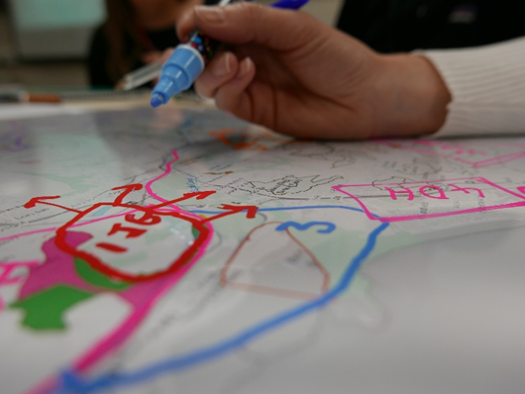
So far, we have tested this internally with our BioCon colleagues and will be rolling this out to external groups over the coming months. We have had good feedback from the session - participants have said the format encouraged practical discussion, creativity of ideas, multifunctional working (breaking out of silos) and new ways to deliver multiple benefits. Most of all, it was a fun exercise!
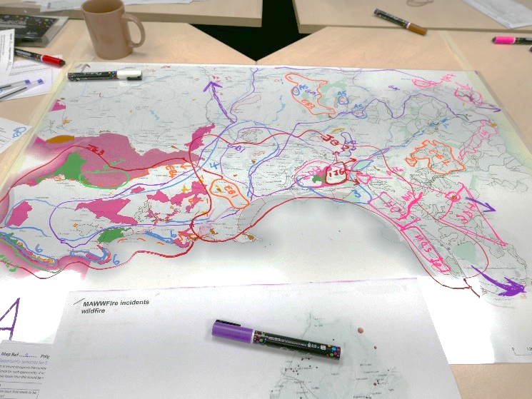
Following the workshop we have digitised all the map polygons onto GIS (screen shot below). Each of the Opportunities have been entered onto EfAST (‘Engagement for Area Statements Tool’) for analysis and prioritisation later. When we look at the opportunities from across SW, we can look for hot-spot areas for delivery.
As part of our SW external engagement we plan to run similar participatory mapping sessions with our Local Nature Partnerships and at county-wide ‘Opportunity Workshops’ which will include a wide range of different stakeholders.
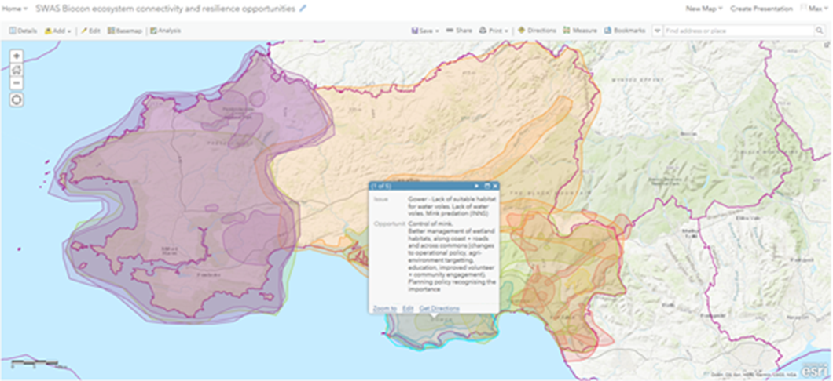

Next Steps
The focus of the Core Group is likely to galvanize around a few key areas:-
- Education and awareness raising – role of GI in supporting wellbeing; what is good about the county (link to Nature plan)
- Developing networks for sharing information and ideas – what is going on and where; asset sharing (knowledge, skills, equipment, land, volunteer time);
- Developing best practice for GI enhancement – developing case studies; utilising public estate
Regional GI/ENRAW project – will build upon the learning from the initial project and facilitate further delivery of GI improvements/interventions.

Well-being Objective Six – Digital Inclusion
Tackle Digital Exclusion (Lead: Assistant Chief Executive, Neath Port Talbot County Borough Council)

Partners/Stakeholders Involved:
Natural Resources Wales; Neath Port Talbot County Borough Council; Swansea Bay Health Board; NPT College Group; South Wales Police; Mid and West Wales Fire and Rescue Service; Tai Tarian; Neath Port Talbot Council for Voluntary Service; Third Sector organisations; Digital Communities Wales; Department for Work and PensionsT; Rural Development Fund.

Key Achievements during 2018-19:
A Digital Inclusion Ambassador post was established with support of Rural Development Programme funding to help move the priorities for building capacity and capability in the local Third Sector forward.
An awareness raising event was held in February 2019 for the Third Sector where information on raising funds on-line; accessing support from Digital Communities Wales; skills and training was available to those attending.
A Steering Group led by the Third Sector is now in place and will develop and implement a programme of work to build capacity and capability over time, supported by the Digital Inclusion Ambassador.
All PSB partner organisations were surveyed to establish how far they had been able to progress the commitment given by PSB partners to work to the Digital Inclusion Charter, supported by Digital Communities Wales. Whilst agencies are at different stages in their work, it is quite clear that the priority being given to this area by the PSB has raised the importance of tackling digital inclusion across agencies.
The work done by partners to date has been captured in a matrix and this is being used within the Digital Inclusion Strategic Group to share learning and to generate mutual support amongst partners. Digital Communities Wales has engaged with the Strategic Group and it is hoped that this will lead to more agencies being confident to pursue formal accreditation against the Charter.
The importance of addressing digital inclusion has continuously been raised as a matter for consideration across all the well-being objectives as the other lead officers have developed their programmes of work to deliver the Well-being Plan.
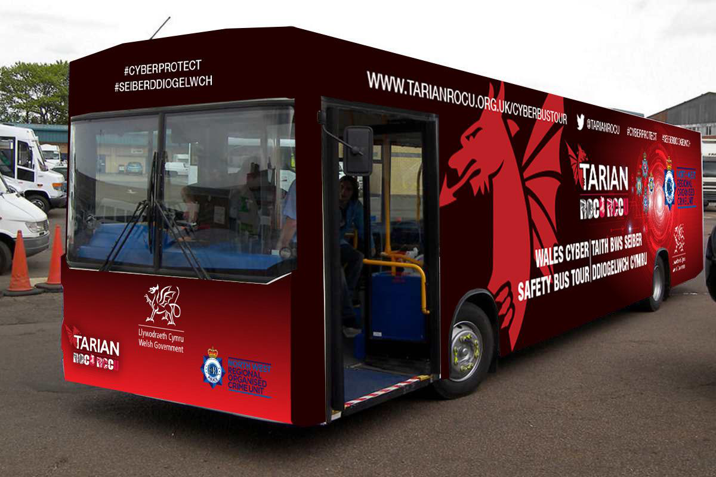
South Wales Police have delivered a range of awareness raising activities across the county borough regarding cyber-crime prevention. As one of the barriers to digital participation, building trust and confidence to use on-line services safely is a key priority. The Community Safety Partnership – Safer Neath Port Talbot has adopted this as one of its three priorities in 2019-20 with early action focused on identifying a set of common messages that all partnerships can convey in the course of their day to day work to help more people stay safe on-line.

A Case Study:
We have learned that cyber-crime is now a very significant threat as more and more people use the Internet to support their daily lives. Whilst many of us will be familiar with cases of fraud - for example when people steal your on-line identity and use that to commit crime – we have become aware of a much wider range of risks and threats that we need to address as part of our work. For example, people using the Internet to help them find a partner can find themselves being hoodwinked by unscrupulous people not even resident in the UK; the Internet is also a space where there is significant exploitation of vulnerable people taking place - child sexual exploitation; radicalisation for terrorist or extremist purposes – being two of many examples; and offences of harassment and stalking on line are also seeing an increase as more and more people use social media accounts in daily life.
There are significant benefits to be gained from being on-line so it is vitally important that we all work together to ensure that people have the skills, knowledge and confident to use the Internet safely.

Next Steps
- Continue to build capacity and capability across the local Third Sector, supported by the Digital Inclusion Ambassador and Digital Communities Wales
- Deliver a cyber-crime prevention campaign across the county borough, through the Safer Neath Port Talbot partnership.
- Continue to encourage PSB partner agencies to work towards formal accreditation against the Digital Inclusion Charter. Facilitate a Strategic Forum where agencies can share the detail of this work and identify areas where joint action would be beneficial.
- Continue to raise the profile of digital inclusion across the Public Services Board’s other areas of work.
- Start to explore how the Get NPT On-Line network can be strengthened and how it might play a long term role in sustaining progress in this area of work.
- Establish how the digital capacity and capability of the private sector locally is being addressed.

Other Work Progressed by the Neath Port Talbot Public Services Board in 2018-19

Board Development
The Board took up the offer of training and development from Academi Wales. The training focused on the governance issues that need to be in place to support effective joint working arrangements. Further development opportunities for the Board will be explored in the next planning period.

Town and Community Councils
During the year, as well as having a representative from town and community councils on the Board itself, discussions took place with those town and community councils who have duties placed upon them by the Well-being of Future Generations (Wales) Act 2015. Each of those town and community councils have prepared statements that set out how they are supporting the achievement of the well-being objectives set out in the Well-being Plan and those statements will be formally considered by the Public Services Board to inform its work going forward.
A copy of the statement provided by Blaenhonddan Community Council is available via the link below:
http://www.blaenhonddan-wcc.gov.uk/wp-content/uploads/2019/05/Annual-Report-2019.pdf
Links to the statements provided by Neath Town Council and Coedffranc Town Council will be added once they are published on their websites later this year.

Substance Misuse
Following reports of high levels of drug-related deaths; serious infection and a growth in organised crime across the area, the two public services boards of Neath Port Talbot and Swansea agreed that a heightened level of attention was required across agencies. A Critical Incident Group was formed with membership drawn from a wide range of agencies to assess the risk, threats and harm in detail and to activate an immediate and appropriate response.
The Critical Incident Group met between September 2018 and February 2019. Key actions completed included:
- Reduction in long waits for drug treatment services;
- Introduction of a pilot outreach service targeted at people deemed at high risk of overdose, serious infection or death;
- Strengthening the Area Planning Board to respond to the needs of people in the area;
- Comprehensive awareness raising programme to build knowledge and understanding across agencies and within communities of the organised crime gangs behind County Lines, including how to spot concerns and how to report them;
- Multi-agency operations across the county borough to tackle drug dealing and to support vulnerable people caught up in the criminal gangs;
- Enhanced programmes across schools, youth services and further/higher education to equip teachers, teaching assistants and learners with knowledge and skills about county lines, substance misuse and how to respond to situations; and
- Joint working to provide more effective responses to people in a mental health crisis; with an acute health need; and children who are missing from residential care homes in the area.
The two public services boards will meet at least twice in the next twelve months to monitor progress. Accountability for delivering the next phase of actions has set been set out in an action plan agreed by both boards.

Early Years
The Neath Port Talbot Public Services Board was invited to take part in two Welsh Government programmes:
- First 1,000 Days; and
- Early Years Pathfinder.
As the programmes were seen to be complementary to Well-being Objective One, the Board agreed to participate in both programmes. The primary reason for participation is the benefits that should be delivered through the learning and research that will be available from across Wales and more widely.
A workshop for front line practitioners to raise awareness of the First 1,000 Days programme was very successful, with the number of people attending the Neath Port Talbot event the highest to date in Wales. There were five themes identified on the day that the PSB has endorsed:
- Placing the leadership for this work with the Think Family Partnership;
- Aligning all of the programmes with Well-being Objective One;
- Sustaining the level of multi-agency engagement;
- Aligning the programme with the Early Years Pathfinder work; and
- Regular reporting of progress to be made by the Think Families Partners to the Public Services Board.

Suicide Prevention
Work undertaken by Public Health Wales identified suicide prevention as an issue that needs greater attention across the Neath Port Talbot and Swansea region.
Recognising that the causes of suicide are complex, the two public services boards have agreed to collaborate with a view to establishing what action can be taken to reduce the rates of suicide. The first meeting of the two boards will take place in June 2019. In agreeing the actions to be taken forward, the public services boards will ensure that there is a clear line of communication to the West Glamorgan Regional Partnership Board so that any actions addressed to health and social care can be incorporated into the work of that partnership.

Physical Activity Alliance
The Board received a report from the Physical Activity Alliance which had formed to ensure organisations working to encourage greater physical activity were working together.
Lead Officers will consider how the recommendations of the Physical Activity Alliance report can be integrated into their Well-being Objectives going forward.

Collaborative Working
A condition of the Welsh Government Grant that supports PSB Co-ordinator posts is that there should be consideration of working regionally where this makes sense.
A number of activities have been carried out jointly with the public services boards of Bridgend and Swansea. These include:
- Joint training for report authors in Easy Read writing approaches;
- Consideration of the respective roles of the public services boards established under the Well-being of Future Generations (Wales) Act 2015 and the regional partnership boards established to take forward reform of health and social care services. Key actions from this work include:
- Focusing the work of PSBs on primary prevention with RPBs taking responsibility for secondary and tertiary prevention; and
- Holding a joint annual event to celebrate achievements and share learning.
- Meetings between the PSB Co-ordinators and between the Lead Officers have also identified some common themes that will be explored in the next twelve months:
- adopting a consistent approach to asset mapping;
- information sharing;
- data analysis;
- evaluation;
- developing new methods of engagement such as digital stories;
- workforce development (making every contact count).

It has been agreed that more regular meetings between co-ordinators and between lead officers will be scheduled in 2019-20. It was also agreed that agencies should be encouraged to reflect the PSB’s well-being objectives in agency corporate plans and across partnership structures.
Partners are clear that the Well-being of Future Generations Act expects us to work differently. The Board regularly challenges itself to respond to this expectation. There is evidence of partners taking a different approach, however, it is equally clear that this is sometimes challenging, particularly for partners who work across Local Authority boundaries.

How can you track progress and get involved in our work?

The work undertaken by the Public Services Board is published on its website which can be accessed via: http://www.nptpsb.org.uk/
On our website you will find details of our Engagement Scheme which sets out a range of ways in which you can get involved in our work.
You can also contact our Public Services Board Co-ordinator directly: e-mail nptpsb@npt.gov.uk or Telephone: 01639 763119. We welcome involvement in any area of our work and we would also welcome ideas and suggestions as to other areas of work that we could consider for the future.

If you require this document in a different format, please contact the Public Services Board Co-ordinator on 01639 763119, email nptpsb@npt.gov.uk or write to Public Services Board Co-ordinator, Port Talbot Civic Centre, Port Talbot, SA13 1PJ

