

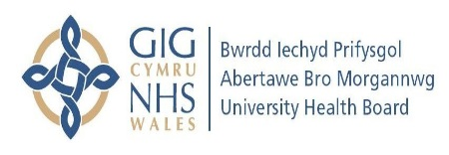
PLEASE REMEMBER
It is your responsibility to:

- Attend scheduled appointments or to notify the Community wound care clinic administration team clinic if you are unable to attend.

- Obtain prescriptions supplied by or requested by the wound care clinical staff.

- Ensure you bring your nursing documentation to each appointment to ensure continuity of treatment plan and care.

Contact Information

If you need to contact the Community Wound Care Clinic

About your appointment

If you are unable to attend

If you have any queries about your appointment or treatment plan

Please ring the following number

Community Wound Care Clinic

Tel: 01792 530783

We strive to continually improve the quality of the service provided. If you have any comments or suggestions, please contact the complaints and Feedback Team on 01639 683363

Community Wound Care Clinics

Patient Information



Our aim is to improve wound healing through consent, support, cooperation and co-production.

Appointment Schedule
First Appointment

What to expect at your first appointment
- We will carry out a full holistic nursing assessment of your needs.
- An appropriate management plan will be developed in collaboration with you and initiated for a minimum of 2 weeks before alternative dressing products will be usually be reconsidered.
- This will be regularly reviewed with you and /or your carers involvement

- Your first appointment will be approx 40 minutes
- Please bring your Medical history and list of your current medication

How to access our service
- Your hospital nurse, Community Nurse, GP or another health professional can refer you to our service.
- Appointments will be made for ongoing care.
- Failure to attend your appointments at wound clinic on 2 occasion without contacting us will result in you being off listed from the service.
- A new referral will be required to reassess the service.
- The community wound care clinic service will provide ongoing advice and support.

Please note that the Community Wound Care Service is not an emergency service. In the event of an emergency you should contact your GP.

The wound clinic service provides a service between Monday and Friday, by scheduled appointment only.
- The Community Wound Care Clinics work closely with the Tissue Viability Nurses, Lymphoedema Clinic and Podiatry Services. When necessary we will, with your consent, communicate with these and other health professionals including GP and Community nurses regarding your care and refer on as appropriate.
- Our aim is to provide evidenced based nursing care for patients with a variety of wound types.
- We will work with you in partnership to develop a plan of care that best suits your needs.
- We will work with you to educate you and /or your carers about how best to look after your wounds.
- We use a variety of wound healing methods and require you to adhere to the treatment plan.

About our service

