What can you do?
- If you think that you are having any of these problems due to your use of paracetamol, please make an appointment to discuss with your GP or Practice Pharmacist.

Alternatively, you can speak to your Community Pharmacist without an appointment

- Try reducing how much paracetamol you use e.g. if you’re taking 2 tablets four times a day, try taking 2 tablets three times a day or maybe 1 tablet four times a day and see if you notice any real difference after a couple of weeks.
The likelihood is that fewer tablets will not make much difference to the level of pain relief you have

- If you want to try without paracetamol altogether, then it is safe to just stop taking it. You may feel that your pain increases for a few days, but this will settle, and it is unlikely you will have any problems. After that, you may choose to only take paracetamol when you think you really need it e.g. for a headache or when your pain feels worse than normal. This is a sensible way to use it and you may feel more benefit from using it like that
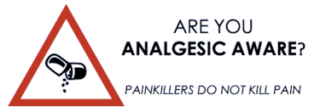

Information about long-term
paracetamol use

Paracetamol has been recommended and prescribed to help treat pain for over 60 years. Recently however, research suggests that it may be less effective in certain types of pain than previously thought. In addition, there are concerns that it may cause side-effects or contribute to other health concerns, more often than realised before. You may take paracetamol on its own or in products such as co-codamol or co-dydramol.

Types of pain that paracetamol might not be effective for
- Back pain – new (acute) or long-term (chronic)
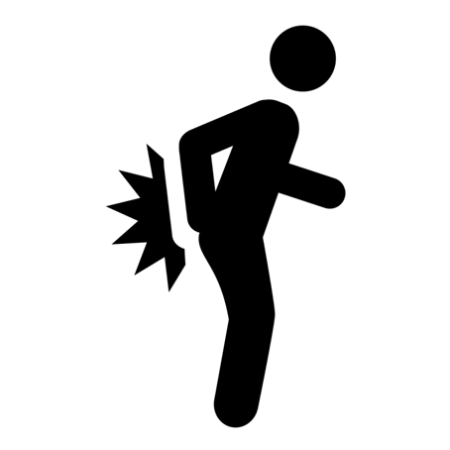
- Osteoarthritis – sometimes referred to as ‘wear and tear’
- Neck pain – due to changes in the spine or muscles
- Rheumatoid arthritis – where other medicines are generally more helpful

Paracetamol has been associated with
- Gastrointestinal (stomach and gut) problems including ulcer
- Increased cardiovascular risk (may include heart attack and stroke)
- Changes in kidney function
- 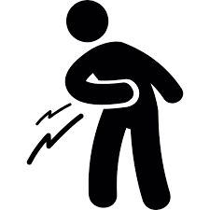Changes in liver function – this can be without taking too much

People who might be most at risk of these problems

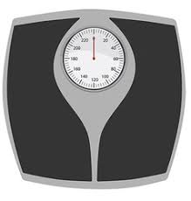
- Low weight (less than 50kg) or people with sudden weight loss

- Older people e.g. those aged 70 years or more
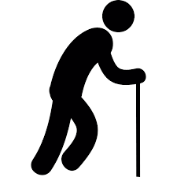

- Frail health – perhaps due to other medical conditions or a sudden illness

- Malnourishment – this may be due to other health conditions but can include people who have not been eating well for a couple of days or more due to illness
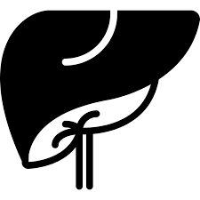
- Known liver changes – may be due to other medicines e.g. carbamazepine, phenytoin; regular high alcohol intake, or an underlying liver disease

If your Healthcare Team are aware that you are in any of these groups, your paracetamol dose may be reduced. This is to ensure that your prescription is as safe as possible.

